**Tsunami Risk and Mitigation Strategy in Lincoln City, Oregon**

Pela Napoleon

GEOG 451

December 5, 2022

Table of Contents

*Chapter 1: Baseline Conditions* ……………………………………………………………………….... 2

*Introduction* ……………………………………………………………………………………………. 2

*Hazard Exposure* …………………………………………………………………………………….. 2

*Sensitive Populations* ……………………………………………………………………….…….. 3

*Adaptive Capacity* ………………………………………………………………………….....…… 3

*Chapter 2: Goals and Methods* ……………………………………………………………….….…….. 8

*Goals and Policy Objective* …………………………………………………………..…………. 8

*Policy Objective #1* ……………………………………………………………………..……..…… 8

*Policy Objective #2* ……………………………………………………………………..………... 10

*Chapter 3: Results* …………………………………………………………………………………………… 12

*Policy #1* …………………………………………………………………………………………..…… 12

*Policy #2* ……………………………………………………………………………………………….. 15

*Chapter 4: Recommendations* …………………………………………………………………………. 19

*Review and Recommendations* ……………………………………………………………... 19

*Next Steps* …………………………………………………………………………………..………… 20

*Conclusion* ………………………………………………………………………………….………... 20

*References* …………………………………………………………………………………………..……….... 22

Chapter 1: Baseline Conditions

This chapter provides an introduction to the community behind this analysis: Lincoln City, Oregon. Basic demographics and town livelihoods are described, as well as sensitive populations. Sensitive populations are a subdivision of the general population that may be more at risk for a natural hazard. The hazard risk for Lincoln City is described, as well as the community’s ability to recover after.

## Introduction

Lincoln City is a modest town of 9,979 people located on the Oregon Coast [5]. Acting as a getaway for those living in the nearby Willamette Valley, Lincoln City attracts a lot of people that come to visit the beaches and other recreational activities. Nearby Cascade Head is a popular hiking route that provides a wide view of the Oregon Coast from above. A short distance south along the coast is the small town of Depoe Bay which is a prime location for whale-watching. These attractions make Lincoln City a major tourist destination. Much of the local economy is built on the influx of people in the summer months.

## Hazard Exposure

About 100 miles off the Oregon Coast lies the Cascadia Subduction Zone (CSZ). Here, the Juan de Fuca tectonic plate meets the North American tectonic plate where they are in the active motion of converging. Over the past few thousand years, the Juan de Fuca plate has been submerging itself beneath the North American plate. This process has periodically caused earthquakes and tsunamis along the Oregon Coast. Earthquakes measured to be over 9.0 in magnitude have occurred in the past, the last one being in 1700 BCE. Because of the data collected, scientists have been able to determine that 9.0 magnitude earthquakes occur once about every 300 years [2]. This means that the Oregon Coast is overdue for another 9.0 magnitude earthquake.

Current scientists believe that there is a 37% chance that a 7.0+ magnitude earthquake can happen within the next 50 years, meaning an earthquake and a tsunami are real threats to the modern Oregon coast [2]. A 9.0 magnitude earthquake will cause ground shaking for at least four minutes and drop the coastline up to 100 feet. The shaking will cause structural damage to buildings along the coastline. Key infrastructure like roadways can become unusable due to fallen debris or inadequate structural integrity. An estimated 15 minutes after the shaking, a tsunami is set to come [8]. This would compound with the earthquake. A wave as big as 100 feet could crash into the already crippled communities of the Oregon Coast and cause further extensive damage [2]. One of these communities would be Lincoln City.

## Sensitive populations

A sensitive population is a subgroup of people out of the general population that are more at risk for a hazard. The entire community of Lincoln City is at risk for a tsunami, but certain portions of the population can be more vulnerable to it than others.

One such population can be seen with low-income. Before a hazard strikes, people with a high income have more flexible options in preparing. Supplies that could be necessary and lifesaving in the aftermath of a hazard can go unpurchased and threaten the lower income population. There is also the case of insurance. A lower income person may not be able to afford good insurance to protect them after a hazard. Much more would be at stake for them if the flooding damaged their home or livelihood.

Proximity to critical facilities can act as another indicator for sensitive populations. Critical facilities are facilities where the risk of flooding poses too great of a threat to the community [4]. This is because these facilities tend to be locations where impacted populations can go in the aftermath of a hazard for help. Included in this definition are hospitals, fire stations, and schools. Professional medical aid and shelter can be provided at these facilities. Being located further away from such a facility can leave a person more vulnerable because they lack that aftermath aid.

A third sensitive population can be seen in the Hispanic population. As of the 2020 US Census, 87.0% of Lincoln City’s population identifies as white. The remaining 13.0% is left to minority groups, of which the Hispanic population makes up 10.4% [9]. Historically, marginalized populations have been found to be more sensitive to natural hazards based on institutional issues. For this analysis, the Hispanic population was chosen to represent minority populations because it is the biggest minority population in the community.

## Adaptive Capacity

Adaptive capacity is a term used to refer to a community’s ability to recover after a hazard. For Lincoln City, the adaptive capacity is low. A 9.0 magnitude earthquake and the subsequent tsunami can have serious impacts on the community.

Lincoln City is situated along US Highway 101. The two ways into town rely on the highway. But, as seen in Figure 1.2, the tsunami has potential to inundate Highway 101 at the north and south ends of town. This would effectively block any entry or exits from the town until the water recedes and the debris clears. Having these points blocked can make it difficult for outside aid services to work their way into the community. Lincoln City would essentially be an island and need to be able to survive on its own.

There are programs in place within the community to increase preparedness for the hazard, but they seem mostly ineffective. One of these programs is the Certified Emergency Response Team (CERT). CERT is a FEMA supported program that aims to teach people about the natural hazards that may impact their community and how they can prepare for it. According to the 2020 annual report, the Lincoln City chapter of CERT only has 26 active members, but this number tends to vary. Chapter membership seems to shift a lot, as people depart or retire from the work. This varying membership number also impacts leadership within the program, as leadership has tended to change frequently. Lack of consistent leadership can inhibit the programs progress. Coupled with this, the organization also lacks funding [1]. This makes it difficult for the program to achieve its desired goals in emergency preparedness. For being under such a serious threat, Lincoln City does not seem prepared enough to successfully recover after the Cascadia Subduction Zone event.

Figure 1. : This map shows the extent of the tsunami inundation zone overlaying block groups showing annual per capita income.

Figure 1. : This map shows the extent of the tsunami inundation zone and the locations of critical facilities in Lincoln City by facility type.

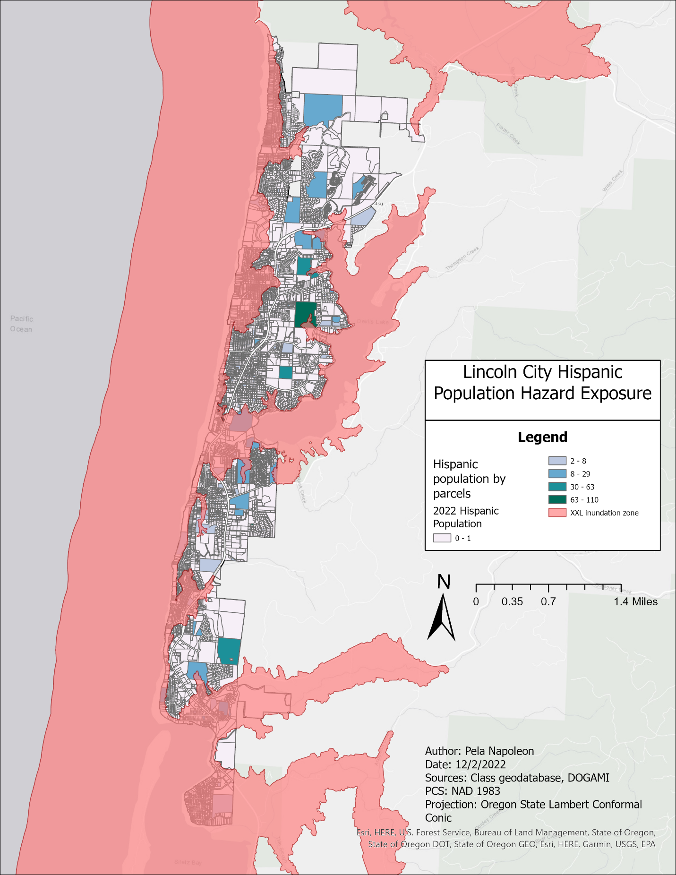

Figure 1. : This map shows the extent of the tsunami inundation zone across parcels in Lincoln City that are classified by Hispanic population.

Chapter 2: Goals and Methods

In this chapter, the goals and policy objectives meant to mitigate hazard vulnerability are stated. After, the methods used to determine the results of the policy objectives are explained. The software ArcGIS Pro was used to formulate these results. ArcGIS Pro is a GIS software that allows users to display and analyze spatial data.

## Goals:

1. Reduce the hazard risk of those living within the tsunami inundation zone.
2. Increase the community’s adaptive capacity.

## Policy Objectives:

1. Construct two vertical evacuation towers in the inundation zone to provide evacuation areas for the population within the inundation zone.
2. Establish a new “critical facility” in a low coverage area to provide aid to the impacted population after the tsunami.

## Policy Objective #1: Build vertical evacuation towers

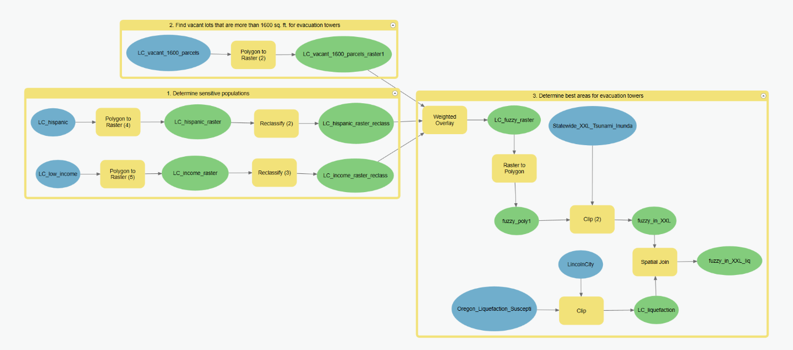

Figure 2. : This model shows the steps taken to determine the best fit areas for two vertical evacuation towers.

To start the analysis, ideal locations needed to be determined.

1. Determine sensitive populations. The three sensitive populations were mentioned back in Chapter 1; low-income population, Hispanic population, and proximity to critical facilities. Low-income populations and Hispanic populations were chosen for this analysis since the evacuation towers could act as a critical facility after construction and thus inherently address the sensitivity of proximity to critical facilities. Layers that show these sensitivities were created from the Enriched Lincoln City parcels layer. Enrich is a tool that adds information on household income and demographics to a layer. The new layer was then converted to a raster and reclassified. The Reclassify tool allows altering of the raster cell values, changing the existing values to something else. For this analysis, the Reclassify tool was used to give pixels with a lower income and pixels with a higher Hispanic population a higher sensitivity value.
2. Find vacant lots that are more than 1600 sq. ft. for evacuation towers. According to information gathered from the Washington Military Department, vertical evacuation towers stand 50 ft tall and 40 ft wide [10]. To find the area that a vertical evacuation tower takes up on the ground, 40 ft was multiplied by 40 ft to get an area of 1600 sq. ft. Then, since the evacuation tower needs to be constructed, the parcels were limited to ones that were vacant. A vacant lot that is 1600 sq. ft is the ideal location for an evacuation tower.
3. Determine best areas for evacuation towers. The two sensitive populations layers were combined with the vacant, 1600 sq. ft layer in a weighted overlay. Weighted Overlay is a tool that overlays different raster layers and weighs values by importance. The vacant parcels were weighted 50%, the low-income population 35%, and the Hispanic population 15%. From this, a fuzzy raster was created that showed the ideal locations from the weighted analysis. This raster was then converted into polygons and clipped to be within the XXL tsunami inundation zone and have a soil liquefaction rating of 0 or 1. The XXL tsunami inundation zone was determined by DOGAMI and models the extent of the tsunami if the CSZ slipped along the entire fault. From this, ideal locations for the evacuation towers were shown as polygons.

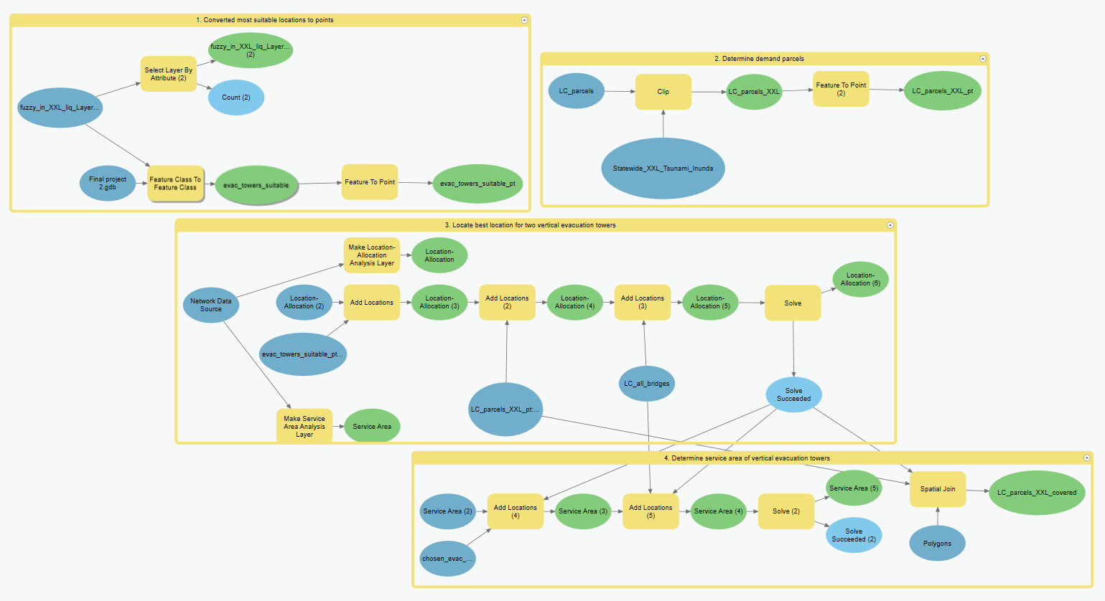

Figure 2. : This model shows the steps taken to determine the two best locations for vertical evacuation towers.

1. Convert most suitable sites to points. Results from the previous model showing ideal locations were then converted into points to be used with the Location-Allocation tool. The tool will be mentioned in depth in the following steps.
2. Determine demand parcels. Parcels that are in the inundation zone were chosen to be the demand parcels. Demand parcels are parcels that will be needing the evacuation tower during the tsunami. This layer was then converted into points to be used with the Location-Allocation tool.
3. Locate best location for two vertical evacuation towers. The Location-Allocation tool was used to determine the two best locations for the evacuation towers. The Location-Allocation tool finds the best location for a facility given certain criteria. For this analysis, the ideal locations were added to the tool as “Facilities,” Lincoln City parcels within the inundation zone were added as “Demand Parcels,” and Lincoln City bridges were added as point barriers. Bridges were chosen as point barriers under the assumption that every bridge in Lincoln City would fail after the earthquake. A 15-minute walking time was used to determine how far out a parcel is covered by the tower. This refers to the estimate that there will be 15 minutes before the tsunami comes after the earthquake [8]. Each tower was given a capacity of 200 people.
4. Determine service area of vertical evacuation towers. The Service Area tool can be used to visualize the coverage a facility can have under certain criteria. For this analysis, the tool was used to determine how many parcels in the inundation zone were within 15-minute walking time from the tower. The chosen evacuation towers layer was added to the tool as a “Facility,” and Lincoln City bridges were added again as point barriers. This allowed the number of parcels covered by the tsunami evacuation towers to be determined.

The results of the analysis will be shown and discussed in the following chapter.

## Policy Objective #2: Build new critical facility

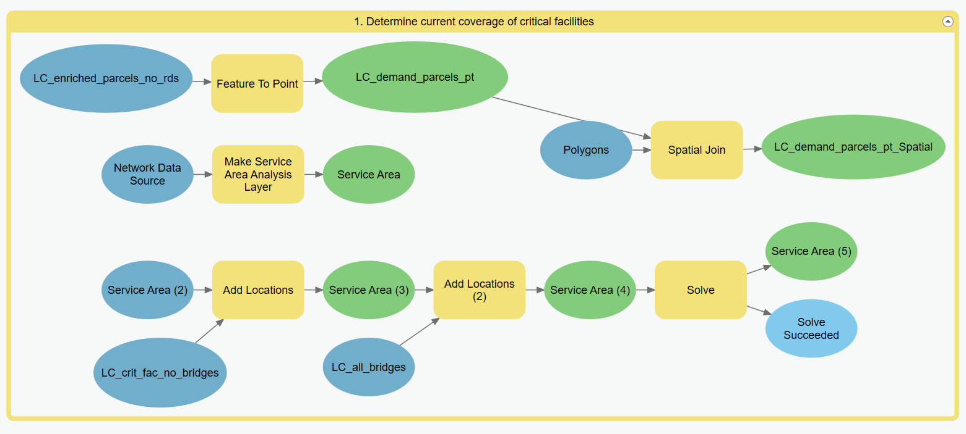

Figure 2. : This model shows the steps taken to determine the current coverage of critical facilities.

To start the analysis, the current coverage of critical facilities needs to be determined to understand the areas of Lincoln City that are not covered.

1. Determine current coverage of critical facilities. The Service Area tool was used again to understand the coverage of current critical facilities. The Critical Facilities layer was added to the tool as “Facilities.” Lincoln City bridge were added again as point barriers. Service area was set to be within one mile walking distance of the critical facility. This distance was used under the assumption that roads would be inoperable after the hazard and impacted populations would have to walk to find aid. One mile was used as the maximum a person would or could walk for aid. After service area for the critical facilities was found, the results were used with the Spatial Join tool to determine the number of parcels covered by the critical facilities. Spatial Join is a tool that combines attributes from one layer with another. Here, the Lincoln City parcels layer was combined with the service area polygons to see the number of parcels covered by current critical facilities.

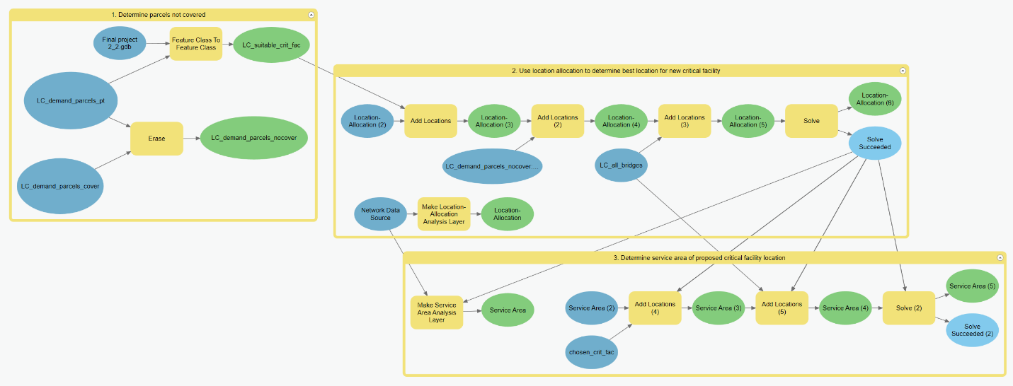

Figure 2. : This model shows the steps taken to find the optimal location to place a new critical facility to service parcels that are not covered by current critical facilities.

1. Determine parcels not covered. To find parcels not covered by current critical facilities, the Erase tool was used. Erase removes aspects of a layer that is found within another layer. For this analysis, the parcels that were determined to be covered by current critical facilities in the previous section were removed from layer that shows all parcels in Lincoln City. This would then show what parcels are not covered by critical facilities. This layer was also used to determine suitable sites for constructing the critical facility. Specific parcels that were vacant, outside of the tsunami inundation zone, and had a commercial zoning status were extracted from the parcels layer and used in the following step.
2. Use Location-Allocation to determine best location for new critical facility. As mentioned in the previous policy analysis, Location-Allocation can be used to determine the best location for a critical facility. The suitable critical facility location layer was added as “Facilities,” parcels not covered by critical facilities was added as “Demand Parcels,” and Lincoln City bridges was again used as point barriers.
3. Determine service area of proposed critical facility location. The Service Area tool was again used to find the coverage of the new critical facility. The chosen critical facility location was added as “Facilities” and Lincoln City bridges were added as point barriers. After this, the number of parcels covered was determined.

The results of the analysis will be shown and discussed in the following chapter.

Chapter 3: Results

In this chapter, the results of the analyses are shown and discussed. Each policy objective is shown with a map that displays the location and spatial extent of each policy. A table is also provided outlining the different affects the policy had on the three chosen sensitive populations; low-income, Hispanic, and proximity to critical facilities, as well as showing the costs and benefits of each policy.

Policy Objective #1: Vertical Evacuation Towers

## Results

|  |  |  |  |
| --- | --- | --- | --- |
|  | Per capita income | Proximity to critical facilities | Hispanic population |
| Baseline | Average of $25,941 in all of Lincoln City. | Critical facilities cover 6,179 parcels. | 1,262 people identify as Hispanic or Latino, according to 2020 Census. |
| Policy #1 | Tower one: Placed in block group with third highest income at $29,411.  Tower two: Placed in block group with second lowest income at $22,564. | The towers cover 2,564 parcels | 59 parcels with at least one person identifying as Hispanic covered by towers. Total Hispanic population covered is 202. |

Table 3. : Results of Policy #1 are shown with impacts on sensitive populations.

The purpose of this policy was to provide an evacuation location for people living within the tsunami inundation zone. During the analysis mentioned in Chapter 2, per capita income and Hispanic population were weighted when determining suitable locations. The two chosen locations took into consideration the weight of each sensitive population.

In one location, the policy was effective in reaching the lower income population. The other location was less effective at addressing this population. Per capita income was determined through US Census data that was on a block group level. Block groups are a subdivision of Census Tracts and are the smallest subdivision that shows per capita income. Per capita income is not displayed on a parcel level as that can be considered an invasion of privacy. Because of this, block groups cover a relatively wide area. There are eight block groups that cover Lincoln City. One evacuation tower was located in a block group that had the second lowest per capita income, while the other was placed in a block group that had the third highest per capita income.

The policy failed to reach the Hispanic population as effectively, though. But this may not be a failure of the analysis, though. Referring back to Figure 1.3 shown in Chapter 1, the Hispanic population tends to be distributed on the eastern half of Lincoln City. This places a majority of the Hispanic population outside of the tsunami inundation zone, and thus less dependent on the evacuation towers.

Since the evacuation towers can act as critical facilities, the sensitivity of being located further from a facility was reduced.

## Costs and Benefits

|  |  |  |
| --- | --- | --- |
|  | Costs | Benefits |
| Policy #1: Vertical evacuation towers | $16 million - $27 million | Increased safety for population living within the inundation zone. Can act as a visual indicator of a high-ground assembly area for those that may not know where high-ground is. |

Table 3. : Costs and benefits of Policy #1 are outlined.

The costs for Policy #1 were determined by finding the average cost for a vertical evacuation tower. According to an independent study, the costs for one tower range from $8 million to $13.5 million [3]. Since Policy #1 proposes constructing two evacuation towers, the average costs had to be doubled. But there is potential to build an evacuation tower for cheaper here on the Pacific coast. In 2018, FEMA approved the construction of an evacuation tower in Washington that would cost $2.5 million [5]. There is no set cost on an evacuation tower, the price varies depending on location.

The benefits of Policy #1 are stated as providing additional evacuation space for those living within the tsunami inundation zone. Since there is an estimated 15-minute time window from the earthquake until the tsunami reaches the shore, those in the inundation zone need to be able to reach a safe area quickly. The evacuation towers can be closer for some than finding high ground elsewhere. There is also the added benefit of providing a visual assembly area for tourists. Community members may know where high ground is, but tourists visiting from elsewhere may not. The evacuation towers can act as a beacon for tourists who do not know where to find high ground.

Figure 3. : This map shows the chosen locations for the vertical evacuation towers, displayed with the star symbol, and the 15-minute walking time coverage of each, displayed in green. The extent of the tsunami inundation zone is shown in red.

## Policy Objective #2: New Critical Facility

## Results

|  |  |  |  |
| --- | --- | --- | --- |
|  | Per capita income | Proximity to critical facilities | Hispanic population |
| Baseline | Average of $25,941 in all of Lincoln City. | Critical facilities cover 6,179 parcels. | 1,262 people identify as Hispanic or Latino, according to 2020 Census. |
| Policy #2 | New critical facility placed in block group with highest annual per capita income at $34,494. | 6,782 parcels are covered in total with new facility. | 31 parcels with at least one person identifying as Hispanic covered by new facility. Total Hispanic population covered is 125. |

Table 3. : Results of Policy #2 are shown with impacts on sensitive populations.

The purpose of this policy was to provide an additional critical facility to aid parcels that were not covered by the current critical facilities. As mentioned in the analysis in Chapter 2, critical facility coverage was determined by a walking distance of one mile. Parcels were considered covered by the critical facility if a person would only need to walk one mile to reach it.

The new critical facility location was not effective at reaching the low-income population. This may not be a failure of the analysis, though. Low-income block groups were already covered by existing critical facilities, as seen in Figure 3.2. The block group with the lowest coverage from existing critical facilities had the highest annual per capita income, so the new critical facility was located there.

The Hispanic population also appears to have been excluded from the analysis, but its reason is similar to the low-income population. Many Hispanic parcels are already covered by existing critical facilities, also seen in Figure 3.2.

The analysis was most effective at limiting sensitivity through proximity to critical facilities. Constructing a new critical facility in an area that is not covered by existing critical facilities inherently lowers this sensitivity metric. More people are thus covered in the event of a natural hazard.

## Costs and Benefits

|  |  |  |
| --- | --- | --- |
|  | Costs | Benefits |
| Policy #2: New critical facility | Purchasing land and construction costs. | Increased aid in the aftermath of the hazard. Potential shelter for impacted population. |

Table 3. : Costs and benefits of Policy #2 are outlined.

The costs associated with Policy #2 center around purchasing land and constructing a facility on it. Thus, the costs can vary depending on the site and construction crew. Some of these costs could be bypassed if the facility was integrated into an already existing building. But during this analysis, a location was chosen that was a vacant lot under the assumption that the facility would be built in its entirety.

The benefits of the critical facility can be seen in the aftermath of the hazard. Critical facilities can be key locations that the community flocks to for aid. As mentioned in Chapter 1, critical facilities include fire stations, hospitals, and schools. Trained professionals in fire stations and hospitals could provide substantial medical aid to those injured during the hazard. Schools are different as they can provide shelter to those displaced. These facilities serve important purposes within the community in terms of recovery. Including another such facility can lower vulnerability to the tsunami hazard and increase recovery within the community. The adaptive capacity of Lincoln City would thus be improved.

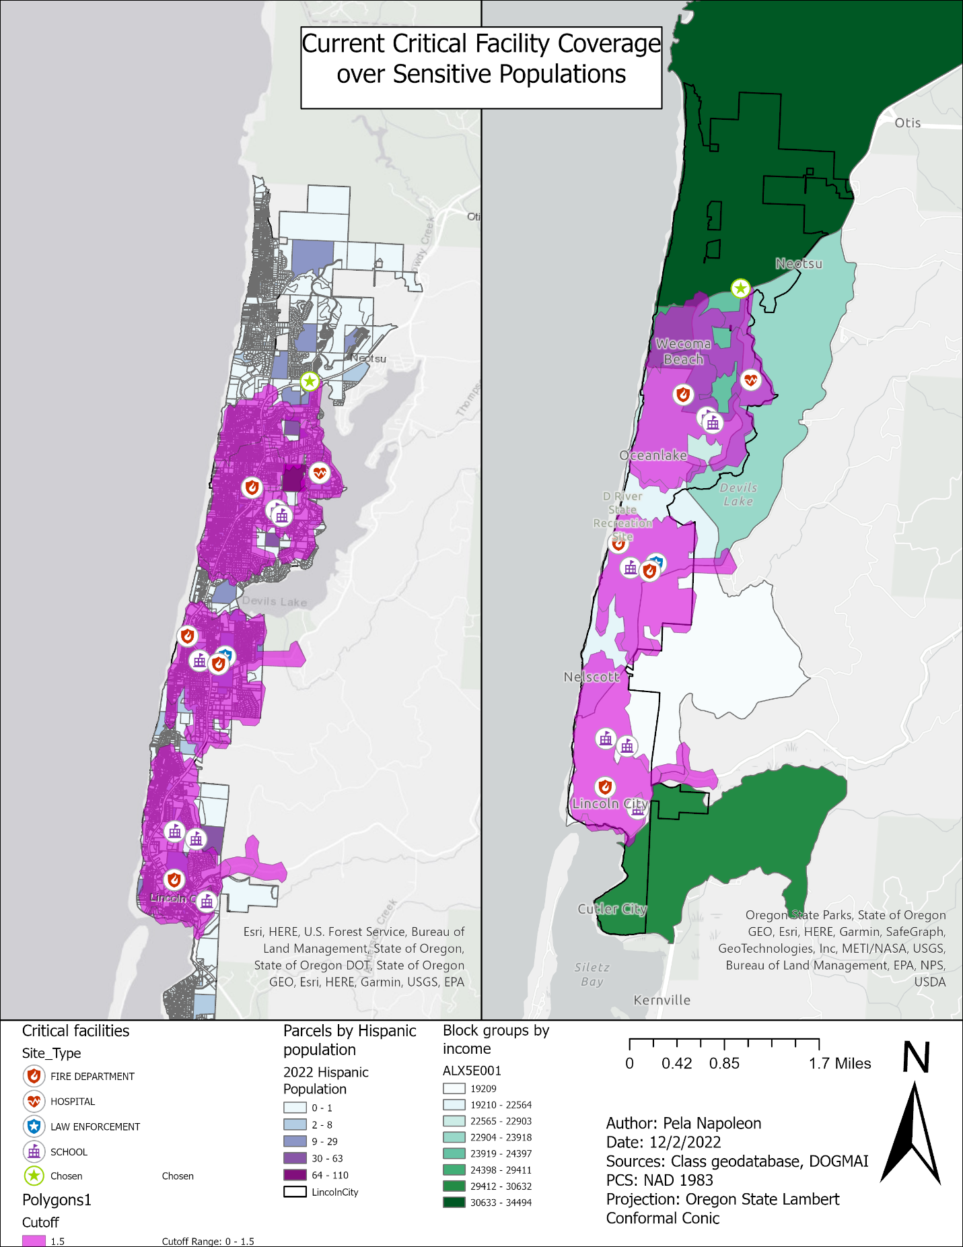

Figure 3. : This map shows the current extent of critical facility coverage over the Hispanic population (left) and the coverage over income groups (right).

Figure 3. : This map shows the current coverage of critical facilities over parcels in Lincoln City (left) and the increased coverage with the proposed new critical facility (right).

Chapter 4: Recommendations

This chapter summarizes the findings of the project and produces recommendations for mitigating tsunami hazard risk in Lincoln City, Oregon.

## Review and Recommendations

|  |  |  |  |  |  |
| --- | --- | --- | --- | --- | --- |
|  | Per capita income | Proximity to critical facilities | Hispanic population | Costs | Benefits |
| Baseline | Average of $25,941 in all of Lincoln City. | Critical facilities cover 6,179 parcels. | 1,262 people identify as Hispanic or Latino, according to 2020 Census. | - | - |
| Policy #1 | Tower one: Placed in block group with third highest income at $29,411.  Tower two: Placed in block group with second lowest income at $22,564. | The towers cover 2,564 parcels | Total Hispanic population covered is 202. | $16 mil. - $27 mil. | Increased safety area during the tsunami |
| Policy #2 | New critical facility placed in block group with highest annual per capita income at $34,494. | 6,782 parcels covered with new facility. | Total Hispanic population covered is 125. | Land purchase and construction | Increased aid access after the hazard |

Table 4. : Summarizing key findings of each policy objective with respect to sensitive populations, while also displaying costs and benefits.

Reviewing the results of the two policy objectives shows various levels of effectiveness at targeting sensitive populations. Each policy had these in mind, but both were not equally successful at reaching them.

Constructing vertical evacuation towers was more effective at reaching vulnerable populations than building a new critical facility. Both the low-income and Hispanic populations were covered in greater numbers under the evacuation towers than the new critical facility. Reducing the vulnerability of these sensitive populations was one of the primary goals of this analysis, as these populations may be impacted unequally. This can be one reason to think that Policy #1 is the better option.

Another reason that Policy #1 may be the better option is its benefit to tourists. One of the faults of this analysis was that it focused only on those that live in Lincoln City. Parcels were used to show population within Lincoln City, but parcels fail to show an influx of people due to tourism. As mentioned in the Chapter 1 introduction, Lincoln City is a tourist town that receives a massive influx of people in the summer months. The excess people may not be as well-versed in evacuation strategies during a tsunami as a local resident might.

It would be difficult to run this analysis with tourists taken into account because the number of tourists vary drastically over the year. According to visitoregon.com, Lincoln City can experience as much as 30,000 tourists during the summer [7]. But, in the middle of winter, there may be no tourists in the community. This analysis can be run under the “worst case scenario” assumption that the tsunami will during peak tourist season, in which case the evacuation towers would be the most effective. But clinging fully to this scenario may be unwise as the number of tourists varies so much over the year. If the tsunami came in the winter months, the evacuation towers may be seen as being less effective.

But still, the evacuation towers have potential to be beneficial to the community at any point in the year. No matter what time of the year the tsunami comes, the evacuation towers can be used by surrounding residents in the inundation zone.

The biggest downside of this policy would be the cost. Average costs for one vertical evacuation tower are high, and city budget may not allow it. The city may be able to apply for outside funding. FEMA has a Hazard Mitigation Assistance Grant that provides funding for “eligible mitigation measures the reduce disaster losses” [6]. Finding funding through this avenue may be beneficial for the community.

## Next Steps

Moving forward, different steps should be taken when considering the implementation of the mitigation policy.

1. Community engagement. It is important to listen to the community when deciding on mitigation strategies. Their input, especially input from sensitive populations, can be important and inform decision makers.
2. Seek out funding from FEMA. FEMA has Hazard Mitigation Assistance Grants that can be used by a community to fund mitigation strategies [6].
3. With given budget, decide how best to proceed. A quota for construction may be higher or lower than estimates. One vertical evacuation tower may be chosen over two.

## Conclusion

After researching about, analyzing, and reviewing data about Lincoln City, it seems obvious that some steps must be taken to mitigate damages from a tsunami. There is serious risk of 9.0 magnitude earthquake to happen within a lifetime, and the community currently seems underprepared. Under this analysis, steps and options were offered that can increase the resilience of the community. ArcGIS Pro was used to spatially show how these options can increase resilience.

But the results of this analysis shouldn’t be taken as real-world fact. Certain limitations are embedded within the analysis; the biggest one being not accounting for tourists. The total number of people in Lincoln City varies drastically through the year, as the community is a summer hotspot for tourism. Including data on tourists can influence the results of the analysis, but this data is seasonal. Depending on what time of the year the tsunami occurs, accounting for tourists can be a good or bad thing for this analysis. Assuming the tsunami happens in the summer, it would be good to include tourists. But if the tsunami is assumed to occur in the winter, tourists would not be appropriate to include.

The analysis can still be used as a recommendation for mitigation strategies. Simulations within the analysis may not be completely accurate, but importance is still held in the results.

References

1. (2020). (rep.). *Lincoln County Citizen Corps Coordinating Council (LC5) Annual Report: July 1, 2019 - June 30, 2020*. Retrieved November 22, 2022, from https://www.co.lincoln.or.us/sites/default/files/fileattachments/emergency_management/page/4631/2019-20_lc5_annual_report_-_lincoln_county.pdf.

2. *Cascadia Subduction Zone*. Oregon.gov. (n.d.). Retrieved November 22, 2022, from https://www.oregon.gov/oem/hazardsprep/pages/cascadia-subduction-zone.aspx

3. Cline, B. (2020, June 9). *Tsunami tower study: Feasible but pricey*. Chinook Observer. Retrieved December 3, 2022, from https://www.chinookobserver.com/tsunami-tower-study-feasible-but-pricey/article_a9a0d780-aa76-11ea-9f3a-2fa214202241.html

4. *Critical facility*. FEMA.gov. (2020, July 7). Retrieved December 5, 2022, from https://www.fema.gov/glossary/critical-facility#:~:text=Typical%20critical%20facilities%20include%20hospitals,alternatives%20and%20floodplain%20management%20plans.

5. *FEMA approves $2.5 million for Shoalwater Bay Indian tribe Tsunami Vertical Evacuation Tower*. FEMA. (2018, June 26). Retrieved December 3, 2022, from https://www.fema.gov/press-release/20210318/fema-approves-25-million-shoalwater-bay-indian-tribe-tsunami-vertical

6. *Hazard mitigation assistance grants*. FEMA.gov. (2022, October 12). Retrieved December 4, 2022, from https://www.fema.gov/grants/mitigation#:~:text=FEMA's%20hazard%20mitigation%20assistance%20provides,and%20property%20from%20future%20disasters.

7. *Lincoln City Oregon Guide and Information: Visit Oregon*. Visit Oregon | Oregon Travel & Vacation Guide. (2021, February 18). Retrieved December 4, 2022, from https://www.visitoregon.com/cities/lincoln-city-oregon/#:~:text=Approximately%209%2C000%20residents%20live%20in,have%20up%20to%2030%2C000%20visitors.

8. Schulz, K. (2015, July 13). *The earthquake that will devastate the Pacific Northwest*. The New Yorker. Retrieved December 5, 2022, from https://www.newyorker.com/magazine/2015/07/20/the-really-big-one

9. *U.S. Census Bureau quickfacts: Lincoln City city, Oregon*. United States Census Bureau. (2021, July 1). Retrieved December 4, 2022, from https://www.census.gov/quickfacts/lincolncitycityoregon

10. Washington Military. (2022, August 17). *Celebrating Nation's first tsunami vertical evacuation tower*. Washington State Military Department. Retrieved December 3, 2022, from https://mil.wa.gov/news/celebrating-nations-first-tsunami-vertical-evacuation-tower#:~:text=The%20tower%20stands%2050%20feet,2%2C000%20square%20feet%20in%20size.